**Environment Toy Model**

I have collected the data from various weather stations. The input data to the program includes following (All these details have been collected at respective weather stations):

**Input format :**

Location|AvgHighTemp|AvgLowTemp|Latitude|Longitude|Elevation|IATA

AvgHighTemp: Annual Highest Average temperature at a particular location (based on weather station data)

AvgLowTemp : Annual Lowest Average temperature at a particular location (based on weather station data)

Latitude/ Longitude/Elevation: Latitude/Longitude/Elevation of the location

IATA : IATA Code of the location

**Sample input data:**

Sydney|26|8|-33.9461|151.177|21|SYD

Melbourne|26|6|-37.6733|144.843|434|MEL

Perth|31|9|-31.9403|115.967|67|PER

Mumbai|33|18|19.0887|72.8679|39|BOM

Chennai|37|22|12.99001|80.1693|52|MAA

Rio de Janeiro|30|18|-22.81|-43.2506|28|GIG

Buenos Aires|29|8|-34.8222|-58.5358|67|EZE

Newyork|29|-3|40.6398|-73.7789|13|JFK

**Output format:**

SYD|-33.9461|151.177|21.0|2016-08-21T02:05:37|Rain|7.61|1010.7|81

MEL|-37.6733|144.843|434.0|2016-08-21T02:05:37|Sunny|5.81|962.2|74

PER|-31.9403|115.967|67.0|2016-08-21T02:05:37|Rain|8.59|1005.2|81

BOM|19.0887|72.8679|39.0|2016-08-21T02:05:37|Sunny|21.49|1008.6|66

MAA|12.99001|80.1693|52.0|2016-08-21T02:05:37|Sunny|25.14|1007.0|52

GIG|-22.81|-43.2506|28.0|2016-08-21T02:05:37|Rain|16.66|1009.9|80

EZE|-34.8222|-58.5358|67.0|2016-08-21T02:05:37|Rain|7.66|1005.2|80

JFK|40.6398|-73.7789|13.0|2016-08-21T02:05:37|Sunny|26.04|1011.7|49

SFO|37.619|-122.375|13.0|2016-08-21T02:05:37|Sunny|20.79|1011.7|69

**Code details:**

**EnvironmentalModel.scala** – main program which will read the input file, strips the necessary data and triggers the respective model programs

**TemperatureConditions.scala** – Module to calculate Temperature values

**humidityConditions.scala** – Module to calculate Humidity values

**pressureConditions.scala** – Module to calculate Pressure values

**WeatherConditions.scala** – Module to calculate weather conditions

**Calculations and Assumptions:**

**Deriving Pressure:** Calculating Pressure is a fairly easy process. Following equation has been used to derive the Atmospheric pressure. This is also called as Barometric pressure formula

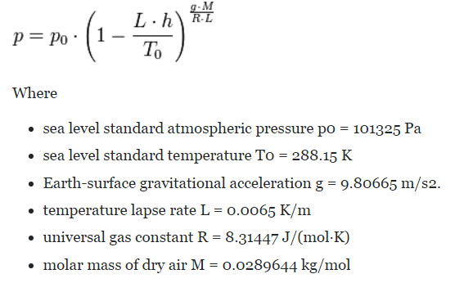

**Deriving Temperature:** Calculating pressure is one of the complex part of the entire model. I have made some assumptions (based on changing geography, seasons etc) while deriving the temperature. I will illustrate those details below:

Firstly, seasons in any part of the world is decided based upon the rotation of the earth ( i.e position of the earth around sun) , Tropic of Cancer, Tropic of Capricorn and Equator. The general thumb of rule is, temperature decreases as the latitude moves farther from Equator. One calendar year is divided into 4 parts

1. Spring Equinox ( Starts on March 21st until June 21st) – During this time the latitudes above tropic of cancer will experience Spring, Between cancer and equator will experience summer, Between equator and Capricorn will experience Autumn and Below Capricorn will experience Winter
2. Summer Solistice (Starts on 21st June until Sept 22nd) - Latitude above Cancer experiences Summer, Between cancer and equator will experience Rainy, Between equator and Capricorn will experience Autumn and Below Capricorn will experience Winter.
3. Autumn Solistice ( Sept 22nd until Dec 23rd) - Latitude above Cancer experiences Autumn, Between cancer and equator will experience Winter , Between equator and Capricorn will experience Spring and Below Capricorn will experience Summer.
4. Winter Solistice ( Dec 23rd until Mar 21st) - Latitude above Cancer experiences Autumn, Between cancer and equator will experience Winter , Between equator and Capricorn will experience Spring and Below Capricorn will experience Summer.

Now based upon the Equinox and Solistice we should be able to determine the season of a particular latitude at a particular time. Since we have the annual average high/low temperatures (from input ). The first assumption is ideally we should have the peak temperature in a year during the middle of summer. Therefore we need to derive the day with highest temperature ( To have the starting point of the graph ) based on the seasons. Similarly identify the day with the lowest temperature ( To frame the curve).

Now , we should be able to calculate the average temperature of the day using trigonometric functions.

General formula is : f(d) = Amplitude * Cos ( (2 . Pi / 365) . d ) + Mean value

Therefore in our situation

1. **Temp(day) = ((Maxtemp – MinTemp)/2) * Cos (( 2.Pi/365) ( Day (Actual date) – Date(Max temp date)) ) + ((MaxTemp + MinTemp)/2)**

If Day (Max temp date ) > Day (Actual date)

1. **Temp(day) = ((Maxtemp – MinTemp)/2) * Cos (( 2.Pi/365) (365 – Date(Max temp date) + Day (Actual date)) ) + ((MaxTemp + MinTemp)/2)**

From the above two formulas we have the average temperature of the day. Now we need to calculate the temperature throughout the day based upon the average temperature. I am assuming the temperature will vary by 10% for every hour in a day ( i.e It can increase by 10% or decrease by 10% based upon the time of day) . Therefore Temperature in a day is again a trigonometric function, which is derived as below:

1. **Temp(day) * (10/100) * cos(( 2* math.pi /(24* 3600)) * (seconds (date)) * -1**

Therefore the final temperature in a day at a particular time is (**(a) + (c))** or (**(b) + (c))**

**Deriving Humidity:**

Relative humidity is the ratio of two pressures: %RH = 100 x P/ Ps

where P is the actual partial pressure of the water vapor present in the ambient and Ps is the saturation pressure of water at the temperature of the ambient.

p = partial pressure of water vapor [Pa]

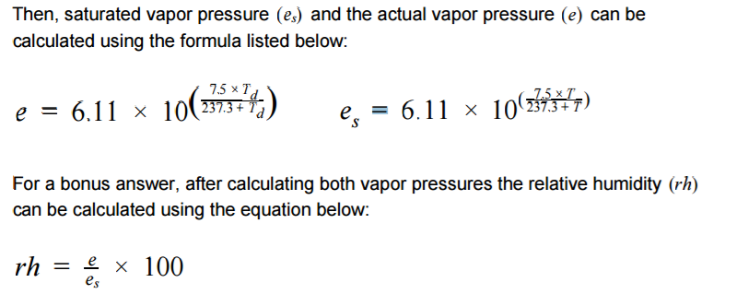

**Vapour Pressure of Water**

The vapour pressure of water, or saturation vapour pressure, increases strongly with increasing temperature:

Source for the below formula:

<https://en.wikipedia.org/wiki/Vapour_pressure_of_water>

<https://en.wikipedia.org/wiki/Arden_Buck_equation>

